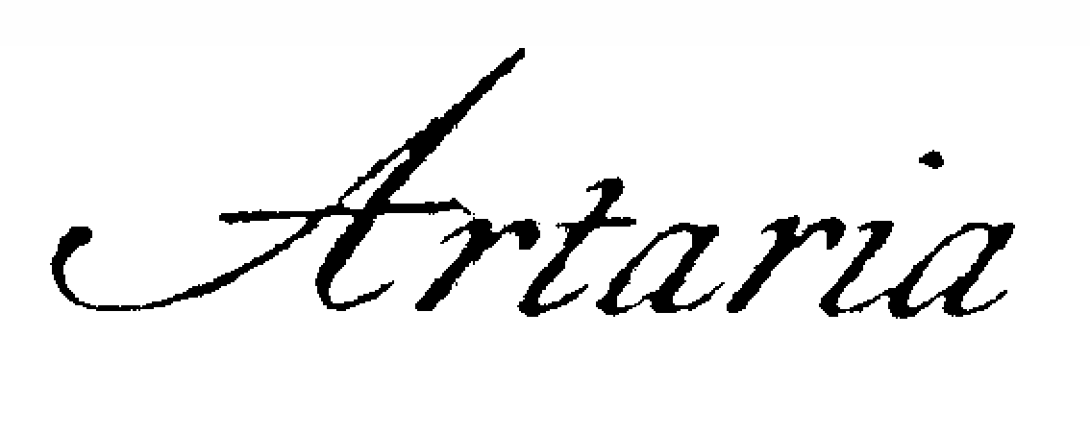
String Quartet

Now in its fourth decade of compelling performances and mentoring of young string players, the Artaria String Quartet was lauded by Rob Hubbard of the St. Paul Pioneer Press -- “Artaria Quartet is likely to give eloquent voice to whatever work it tackles.” Artaria has served as MPR Artists-in-Residence and was featured on Twin Cities Public Television as part of the MN-Original Television series. A finalist at the Banff International String Quartet Competition, the quartet has appeared at major summer festivals including Festival de L’Epau in France, and the Tanglewood Music Center in Lenox, Massachusetts. Artaria is the recipient of a highly coveted McKnight Fellowship for Performing Musicians and has received Teaching Artist grants from the National Endowment for the Arts, Chamber Music America, Midori's Partners in Performance, and the Heartland Fund for performance and educational outreach. They have also been awarded numerous Minnesota State Arts Board grants for creative educational programming across Minnesota. Members of the quartet are founders and directors of the Artaria Chamber Music School, a weekly chamber music program for young string players, Stringwood, a two-week summer festival held in Lanesboro, MN each summer, and the Saint Paul String Quartet Competition, an annual international event that showcases America’s finest young high school and college string quartets.

