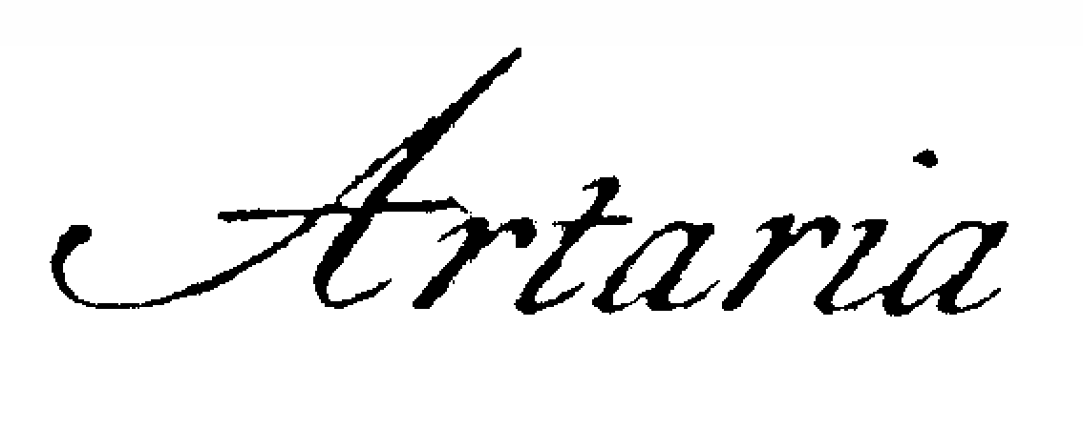
String Quartet

A warm, rich sound and deeply thoughtful musicianship are the hallmarks of the Artaria String Quartet. Named after the Italian publishing house that issued the first editions of many of the great string quartets of Haydn, Mozart, and Beethoven, Artaria has earned critical acclaim in Europe and across the United States for performances that combine refined ensemble playing with interpretive depth. The Boston Globe has described the quartet as “exquisitely balanced and sonorous,” noting that “their musical understanding is first-rate.”

Originally founded in Boston, the quartet was mentored by members of the legendary Budapest, La Salle, Kolisch, Juilliard, Emerson, and Cleveland Quartets. Artaria has appeared on television and live radio and performed at major venues in New York, Chicago, Philadelphia, Washington, D.C., Atlanta, Cleveland, and Boston. A finalist at the Banff International String Quartet Competition, the quartet has appeared at major summer festivals including Festival de L’Epau in France, and the Tanglewood Music Center in Lenox, Massachusetts. In Minnesota, the quartet served as Minnesota Public Radio Artists-in-Residence and has been featured on Twin Cities Public Television’s Minnesota Originals series.

Nationally recognized for both their artistry and their commitment to education, Artaria has been invited to perform and teach at leading summer festivals and educational institutions throughout North America and Europe. The quartet is the recipient of a McKnight Fellowship for Performing Musicians and has received Teaching Artist grants from the National Endowment for the Arts, Chamber Music America, Midori’s Partners in Performance, and the Heartland Fund for community engagement and educational outreach. Artaria has performed thousands of concerts and educational programs, reaching students from across the United States.

Honored with the inaugural Rural Residency Grant from the National Endowment for the Arts, the quartet has helped establish and strengthen string programs in communities throughout the Midwest. Artaria has held residencies at Boston College and Viterbo University and is now based in Saint Paul, Minnesota, where the members are founders and directors of several influential chamber music initiatives:

- Artaria Chamber Music School, a weekly chamber music program for young string players
- Stringwood Chamber Music Festival, a two-week summer festival in Lanesboro, Minnesota
- Saint Paul String Quartet Competition, an international competition featuring the finest high school, collegiate, and pre-professional string quartets.

Firmly rooted in the great canon of chamber music, Artaria is equally dedicated to expanding the repertoire by performing compelling new works. The ensemble has presented widely praised and well attended performances of the complete Beethoven, Shostakovich and Bartók string quartets for the Schubert Club in Saint Paul. Artaria is also a strong advocate for contemporary music and has commissioned and premiered numerous new works.

Educational Initiatives
Artaria believes deeply in the transformative power of music and in the essential role of music education. The quartet’s programs share their passion for chamber music with musicians of all ages and experience levels.

Artaria Chamber Music School
This program trains young musicians in the art of chamber music interpretation while fostering collaboration and musical leadership. Students come from many of Minnesota’s strongest string programs, and graduates frequently win national competitions, attend major conservatories, and perform in leading ensembles throughout the country.

Adult Chamber Music Retreat
Since its founding in 2000, this annual retreat has provided amateur musicians with the opportunity to rehearse, receive coaching, attend seminars, and perform in an inspiring environment. The retreat takes place each September at the Eagle Bluff Environmental Learning Center in the scenic Driftless Region of southeastern Minnesota.

Stringwood Chamber Music Festival
Held each summer at Eagle Bluff Environmental Learning Center in Lanesboro, Minnesota, Stringwood brings together renowned international guest artists, Artaria Quartet members, and talented young musicians ages 13–26. The festival features professional concerts alongside performances by Stringwood Young Artists.

Saint Paul String Quartet Competition
Dedicated to celebrating excellence in quartet playing and strengthening the culture of chamber music in America, the competition showcases the world’s finest high school, collegiate, and pre-professional string quartets—many of whom go on to perform in the leading professional ensembles of the next generation.

“Minnesota’s foremost teaching and performing string quartet, Artaria Quartet is likely to give eloquent voice to whatever work it tackles.”
— Rob Hubbard, Pioneer Press

“The precision of execution was striking… beautifully keen, precise, self-possessed playing.”
— Richard Buell, Boston Globe

* * * * *

